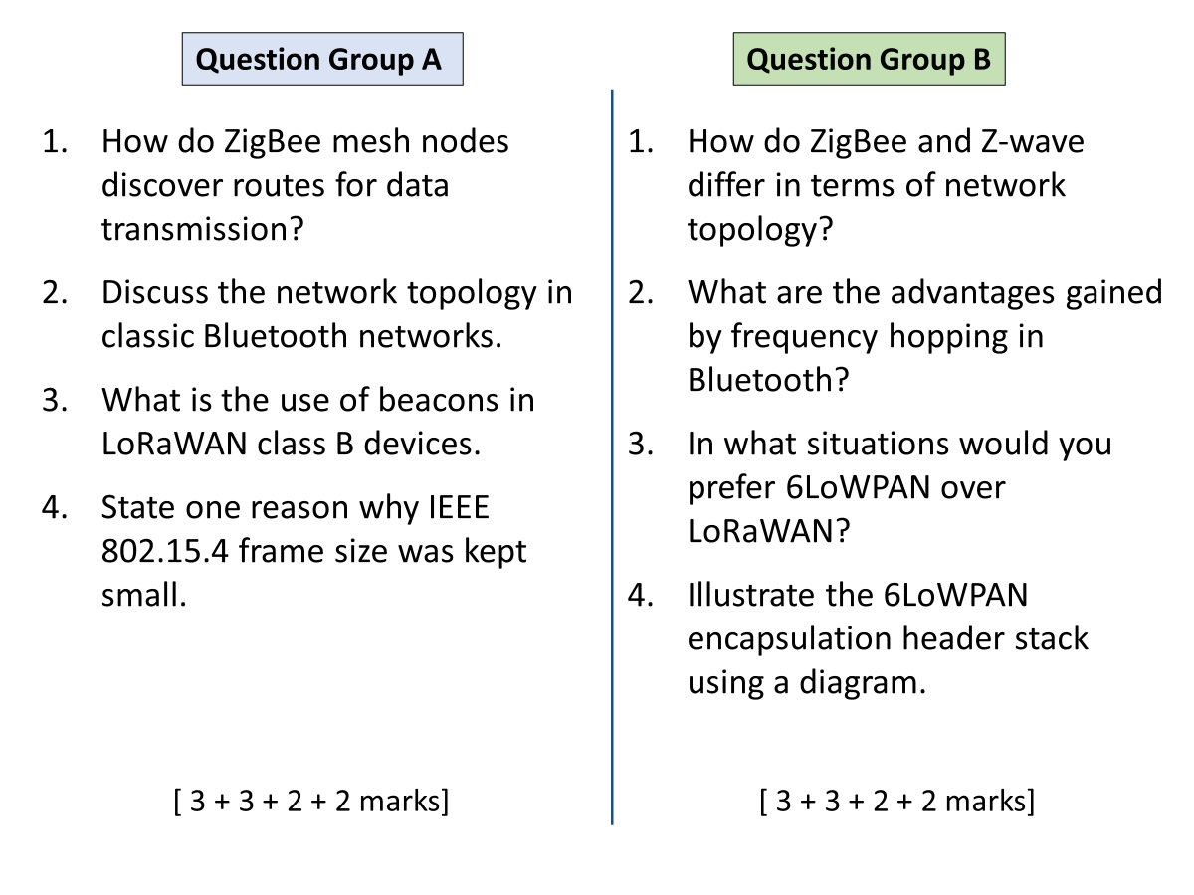

A

1

L9, slide 14

2

L12, slide 6-7

3

Beacons allow nodes to synchronize their clocks with the network server, thus class B devices can schedule their probe slots.

4

L12 slide 6

B

1

Zigbee topology could be star, cluster tree or mesh. There is a coordinator for whole PAN and several routers. End-nodes only connect to their parent.

Zwave is always a mesh. There are one or more controllers, and other nodes are slaves. Slaves forward the data in mesh but do not make routing decisions.

2

Avoiding interferences from other devices using the same 2.4GHz band. Any interference would last only for one hop period.

3

When nodes are only required to communicate over short distances, within meters.

When IP connectivity of individual nodes is desired.

When slightly higher data rates are required, up to 250kbps.

4

L12, slide 20